Produce a mind map of information about the artist Bridget Riley.

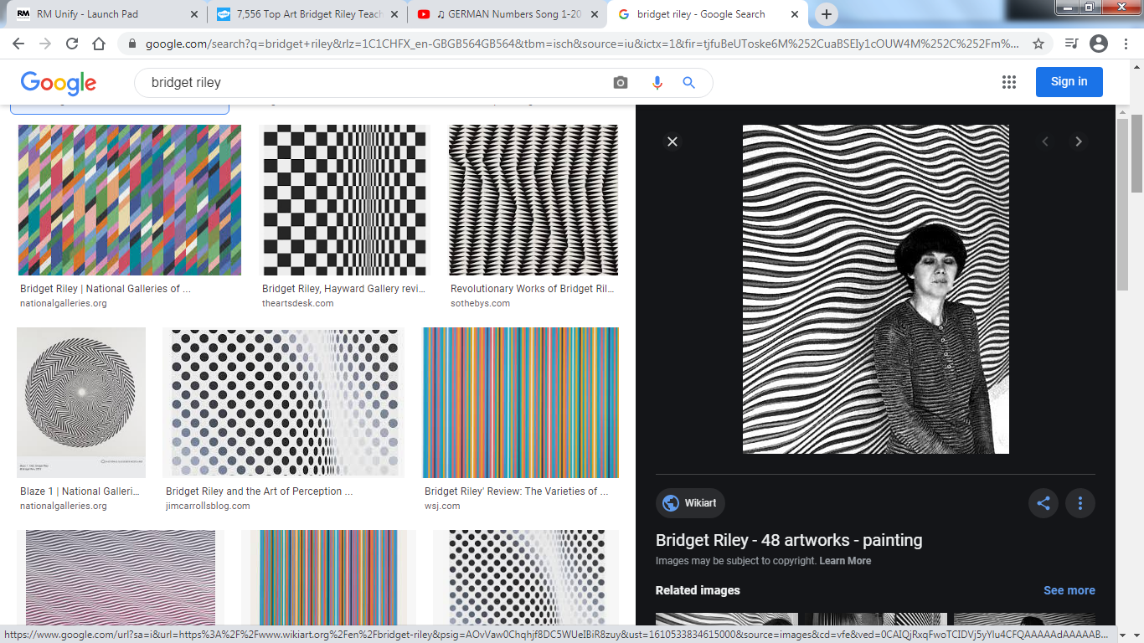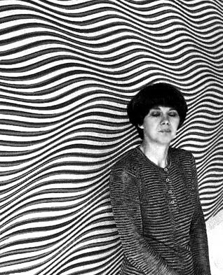

Circle your favourite piece of art work from Bridget Riley.

Why have you chosen the piece of artwork as your favourite?